

Fakulteti I Shkencave Kompjuterike dhe Inxhinierisë

Projekti: Pjesa dytë

SISTEMET E BAZËS SË TË DHËNAVE

Ligjërues : Prof. Ramiz Hoxha

Punuar nga : Elsan memeti

1. Database Diagram 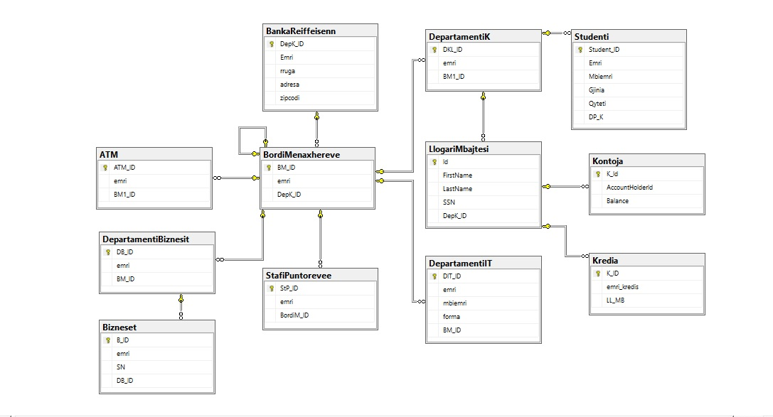

Fig 1: Modeli Relacionar

2. DDL

create database BANKAIME

use BANKAIME

---------------------------------------------------------------------------

create table BankaReiffeisenn(

DepK_ID int not null primary key,

Emri varchar(65),

rruga varchar(40),

adresa varchar(50),

zipcodi char(60),

);

select * from BankaReiffeisenn

INSERT INTO BankaReiffeisenn VALUES (1,'BankaReiffeisenPR','Nene-terez','Baba-Tereze','12000');

INSERT INTO BankaReiffeisenn VALUES (2,'BankaReiffeisenGL','Nene-terez1','Baba-Tereze2','12500');

INSERT INTO BankaReiffeisenn VALUES (3,'BankaReiffeisenFR','Nene-terez','Baba-Tereze3','12600');

INSERT INTO BankaReiffeisenn VALUES (4,'BankaReiffeisenPZ','Nene-terez','Baba-Tereze4','12700');

------------------------------------------------------------------------------------------------

Create table BordiMenaxhereve(

BM_ID int not null primary key,

emriBordit varchar(50),

DepK_ID int,

constraint fk_bordiMenaxhereve foreign key (BM_ID) references BordiMenaxhereve(BM_ID),

constraint Fk_BordiMenaxherevee foreign key(DepK_ID) references BankaReiffeisenn(DepK_ID)

);

INSERT INTO BordiMenaxhereve VALUES (1,'Bordi i Menaxhereve PR',1);

INSERT INTO BordiMenaxhereve VALUES (2,'Bordi i Menaxhereve GL',2);

INSERT INTO BordiMenaxhereve VALUES (3,'Bordi i Menaxhereve FR',3);

INSERT INTO BordiMenaxhereve VALUES (4,'Bordi i Menaxhereve PZ',4);

select * from BordiMenaxhereve

------------------------------------------------------------------------------------------------

Create table ATM(

ATM_ID int primary key,

emri char(40),

BM1_ID int,

CONSTRAINT FK_BordiMENAXHEREV FOREIGN KEY(BM1_ID) REFERENCES BordiMenaxhereve(BM_ID)

);

INSERT INTO ATM (ATM_ID,emri,BM1_ID) VALUES (10,'Ne Qytetin e Prishtines',1);

INSERT INTO ATM (ATM_ID,emri,BM1_ID) VALUES (11,'Ne Qytetin e Gilanit',2);

INSERT INTO ATM (ATM_ID,emri,BM1_ID) VALUES (12,'Ne Qytetin e Ferizajit',3);

INSERT INTO ATM (ATM_ID,emri,BM1_ID) VALUES (13,'Ne Qytetin e Prizrenit',4);

------------------------------------------------------------------------------------------------

Create table DepartamentiIT(

DIT_ID int primary key,

emri varchar(50),

mbiemri varchar(50),

forma varchar(50),

BM_ID int,

constraint Fk_DepartamentiIT foreign key(BM_ID) references BordiMenaxhereve(BM_ID)

);

insert into DepartamentiIT values ('1','erik','thaqi','backand','1');

-------------------------------------------------------------------------------------------

Create table DepartamentiK(

DKL_ID int not null primary key,

emri char(50),

BM1_ID int,

constraint Fk_BordiMenaxhereve1 foreign key(BM1_ID) references BordiMenaxhereve(BM_ID)

);

INSERT INTO DepartamentiK (DKL_ID,emri,BM1_ID) VALUES (10,'Departameni i Klienteve PR',1);

INSERT INTO DepartamentiK (DKL_ID,emri,BM1_ID) VALUES (11,'Departameni i Klienteve GL',2);

INSERT INTO DepartamentiK (DKL_ID,emri,BM1_ID) VALUES (12,'Departameni i Klienteve FR',3);

INSERT INTO DepartamentiK (DKL_ID,emri,BM1_ID) VALUES (13,'Departameni i Klienteve PZ',4);

select * from DepartamentiK

------------------------------------------------------------------------------------------------

create table Studenti(

Student_ID char(5),

Emri varchar (20),

Mbiemri varchar (20),

Bilanci money,

Gjinia char(1),

Qyteti varchar (10),

DP_K int,

Primary Key (Student_ID),

check (Gjinia IN ('M','F','N')),

CONSTRAINT FK_STUDENTI FOREIGN KEY (DP_K) REFERENCES DepartamentiK(DKL_ID)

);

select * from Studenti

insert into Studenti (Student_ID,Emri,Mbiemri,Bilanci,Gjinia,Qyteti,DP_K) values ('100','Liberta','Buja',300,'F', 'PZ',10);

insert into Studenti (Student_ID,Emri,Mbiemri,Bilanci,Gjinia,Qyteti,DP_K) values ('101','Berat','Gashi',400,'M','FR',11);

insert into Studenti (Student_ID,Emri,Mbiemri,Bilanci,Gjinia,Qyteti,DP_K) values ('102','Edita','Syla',250, 'F','PZ',12);

insert into Studenti (Student_ID,Emri,Mbiemri,Bilanci,Gjinia,Qyteti,DP_K) values ('103','Visar','Dema',100,'M','GJK',10);

insert into Studenti (Student_ID,Emri,Mbiemri,Bilanci,Gjinia,Qyteti,DP_K) values ('104','Kushtrim','Hoxha',230,'M','PR',11);

insert into Studenti (Student_ID,Emri,Mbiemri,Bilanci,Gjinia,Qyteti,DP_K) values ('105','Lenonora','Peci',350,'F','PR',12);

insert into Studenti (Student_ID,Emri,Mbiemri,Bilanci,Gjinia,Qyteti,DP_K) values ('106','Kushtrim','Hoxha',360,'M','PR',13);

insert into Studenti (Student_ID,Emri,Mbiemri,Bilanci,Gjinia,Qyteti,DP_K) values ('107','Lenonora','Peci',150,'F','PR',11);

insert into Studenti (Student_ID,Emri,Mbiemri,Bilanci,Gjinia,Qyteti,DP_K) values ('108','Besiana','Shkembi',120,'F','PR',10);

insert into Studenti (Student_ID,Emri,Mbiemri,Bilanci,Gjinia,Qyteti,DP_K) values ('109','Veton','Sopa',210,'M','PZ',13);

insert into Studenti (Student_ID,Emri,Mbiemri,Bilanci,Gjinia,Qyteti,DP_K) values ('110','Alketa','Jakupi',80,'F','FR',12);

-------------------------------------------------------------------------------

CREATE TABLE LlogariMbajtesi

(

Id INT NOT NULL,

FirstName VARCHAR(50) NOT NULL,

LastName VARCHAR(50) NOT NULL,

SSN CHAR(10) NOT NULL,

DepK_ID INT NOT NULL

CONSTRAINT PK_LlogariMbajtesi PRIMARY KEY (Id)

CONSTRAINT FK_LlogariMbajtes FOREIGN KEY (DepK_ID) REFERENCES DepartamentiK(DKL_ID)

);

INSERT INTO LlogariMbajtesi (Id, FirstName, LastName, SSN, DepK_ID) VALUES (1, 'Susan', 'Cane', '1234567890',10);

INSERT INTO LlogariMbajtesi (Id, FirstName, LastName, SSN, DepK_ID) VALUES (2, 'Kim', 'Novac', '1234567890',11);

INSERT INTO LlogariMbajtesi (Id, FirstName, LastName, SSN, DepK_ID) VALUES (3, 'Jimmy', 'Henderson', '1234567890',12);

INSERT INTO LlogariMbajtesi (Id, FirstName, LastName, SSN, DepK_ID) VALUES (4, 'Steve', 'Stevenson', '1234567890',10);

INSERT INTO LlogariMbajtesi (Id, FirstName, LastName, SSN, DepK_ID) VALUES (5, 'Bjorn', 'Sweden', '1234567890',12);

INSERT INTO LlogariMbajtesi (Id, FirstName, LastName, SSN, DepK_ID) VALUES (6, 'Kiril', 'Petrov', '1234567902',13);

INSERT INTO LlogariMbajtesi (Id, FirstName, LastName, SSN, DepK_ID) VALUES (7, 'Petar', 'Kirilov', '1234567890',10);

INSERT INTO LlogariMbajtesi (Id, FirstName, LastName, SSN, DepK_ID) VALUES (8, 'Michka', 'Tsekova', '1234567890',11);

INSERT INTO LlogariMbajtesi (Id, FirstName, LastName, SSN, DepK_ID) VALUES (9, 'Zlatina', 'Pateva', '1234567890',13);

INSERT INTO LlogariMbajtesi (Id, FirstName, LastName, SSN, DepK_ID) VALUES (10, 'Monika', 'Miteva', '1234567890',12);

INSERT INTO LlogariMbajtesi (Id, FirstName, LastName, SSN, DepK_ID) VALUES (11, 'Zlatko', 'Zlatyov', '1234567890',11);

INSERT INTO LlogariMbajtesi (Id, FirstName, LastName, SSN, DepK_ID) VALUES (12, 'Petko', 'Petkov Junior', '1234567890',10);

INSERT INTO LlogariMbajtesi (Id, FirstName, LastName, SSN, DepK_ID) VALUES (13, 'Susan', 'Cane', '1234567890',12);

select * from LlogariMbajtesi

------------------------------------------------------------------------------------------------

Create table Kredia(

K_ID int primary key,

emri_kredis char(20),

LL_MB int

CONSTRAINT FK_LlogariMbajtesi FOREIGN KEY (LL_MB) REFERENCES LlogariMbajtesi (Id)

);

INSERT INTO Kredia (K_ID,emri_kredis,LL_MB) VALUES (20,'ME KAMAT',1);

INSERT INTO Kredia (K_ID,emri_kredis,LL_MB) VALUES (21,'PA KAMAT',1);

INSERT INTO Kredia (K_ID,emri_kredis,LL_MB) VALUES (22,'ME KAMAT',2);

INSERT INTO Kredia (K_ID,emri_kredis,LL_MB) VALUES (24,'ME KAMAT',4);

INSERT INTO Kredia (K_ID,emri_kredis,LL_MB) VALUES (25,'PA KAMAT',5);

INSERT INTO Kredia (K_ID,emri_kredis,LL_MB) VALUES (27,'PA KAMAT',7);

INSERT INTO Kredia (K_ID,emri_kredis,LL_MB) VALUES (29,'PA KAMAT',9);

INSERT INTO Kredia (K_ID,emri_kredis,LL_MB) VALUES (30,'ME KAMAT',10);

INSERT INTO Kredia (K_ID,emri_kredis,LL_MB) VALUES (31,'PA KAMAT',11);

INSERT INTO Kredia (K_ID,emri_kredis,LL_MB) VALUES (32,'MA KAMAT',12);

select * from Kredia

-------------------------------------------------------------------------------------------------

CREATE TABLE Kontoja

(

K_Id INT NOT NULL,

AccountHolderId INT NOT NULL,

Balance MONEY DEFAULT 0

CONSTRAINT PK_Kontoja PRIMARY KEY (K_Id)

CONSTRAINT FK_KontojLlogariMbajtesi FOREIGN KEY (AccountHolderId) REFERENCES LlogariMbajtesi(Id)

);

select * from Kontoja

INSERT INTO Kontoja (K_Id, AccountHolderId, Balance) VALUES (100, 2, 123.13);

INSERT INTO Kontoja (K_Id, AccountHolderId, Balance) VALUES (101, 5, 47354.23);

INSERT INTO Kontoja (K_Id, AccountHolderId, Balance) VALUES (102, 2, 6546543.23);

INSERT INTO Kontoja (K_Id, AccountHolderId, Balance) VALUES (103, 4, 15345.64);

INSERT INTO Kontoja (K_Id, AccountHolderId, Balance) VALUES (104, 5, 36521.20);

INSERT INTO Kontoja (K_Id, AccountHolderId, Balance) VALUES (105, 11, 54367.34);

INSERT INTO Kontoja (K_Id, AccountHolderId, Balance) VALUES (106, 7, 56569.20);

INSERT INTO Kontoja (K_Id, AccountHolderId, Balance) VALUES (107, 12, 99943.50);

INSERT INTO Kontoja (K_Id, AccountHolderId, Balance) VALUES (108, 9, 5349758.23);

INSERT INTO Kontoja (K_Id, AccountHolderId, Balance) VALUES (109,10, 543.30);

INSERT INTO Kontoja (K_Id, AccountHolderId, Balance) VALUES (110,11, 10.20);

INSERT INTO Kontoja (K_Id, AccountHolderId, Balance) VALUES (111, 12, 245656.23);

INSERT INTO Kontoja (K_Id, AccountHolderId, Balance) VALUES (112, 1, 5435.32);

-------------------------------------------------------------------------------------------

Create table StafiPuntorevee(

StP_ID int not null primary key,

emri varchar(50),

BordiM_ID int not null,

constraint Fk_Stafi foreign key (BordiM_ID) references BordiMenaxhereve (BM_ID)

);

INSERT INTO StafiPuntorevee (StP_ID,emri,BordiM_ID) VALUES (10,'Puntoret PR',1);

INSERT INTO StafiPuntorevee (StP_ID,emri,BordiM_ID) VALUES (11,'Puntoret GL',2);

INSERT INTO StafiPuntorevee (StP_ID,emri,BordiM_ID) VALUES (12,'Puntoret FR',3);

INSERT INTO StafiPuntorevee (StP_ID,emri,BordiM_ID) VALUES (13,'Puntoret PZ',4);

select * from StafiPuntorevee

-------------------------------------------------------------------------------------------

Create table DepartamentiBiznesit(

DB_ID int primary key,

emri varchar(50),

BM_ID int,

constraint Fk_DepartamentiBiznesit foreign key(BM_ID) references BordiMenaxhereve(BM_ID)

);

select * from DepartamentiBiznesit

INSERT INTO DepartamentiBiznesit (DB_ID,emri,BM_ID) VALUES (10,'Departamenti i Biznesit PR',1);

INSERT INTO DepartamentiBiznesit (DB_ID,emri,BM_ID) VALUES (11,'Departamenti i Biznesit GL',2);

INSERT INTO DepartamentiBiznesit (DB_ID,emri,BM_ID) VALUES (12,'Departamenti i Biznesit FR',3);

INSERT INTO DepartamentiBiznesit (DB_ID,emri,BM_ID) VALUES (13,'Departamenti i Biznesit PZ',4);

----------------------------------------------------------------------------------------------

Create table Bizneset(

B_ID int primary key,

emriBiznesit varchar(60),

SN char(10),

DB_ID int,

constraint Fk_DepartamentiBiznesi foreign key (DB_ID) references DepartamentiBiznesit(DB_ID)

);

INSERT INTO Bizneset (B_ID,emriBiznesit,SN,DB_ID) VALUES (14,'Al trade',321321,10);

INSERT INTO Bizneset (B_ID,emriBiznesit,SN,DB_ID) VALUES (15,'Metatrade',321321,11);

INSERT INTO Bizneset (B_ID,emriBiznesit,SN,DB_ID) VALUES (16,'Mehana',321321,12);

INSERT INTO Bizneset (B_ID,emriBiznesit,SN,DB_ID) VALUES (17,'Bau Trade',321321,13);

------------------------------------------------------------------------------------------------

Pesë query të thjeshta:

1.Te shfaqet Emri dhe mbiemri i studentit?

select Emri,Mbiemri

from Studenti

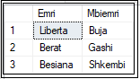

2. Te shfaqet Emri dhe mbiemri i studentit qe permban shkronjen B?

select Emri,Mbiemri

from Studenti

where Emri like '%B%'

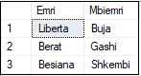

-- te shfaqet ID e Biznesit me emer "Metatrade" ?

select B_ID

from Bizneset

where emriBiznesit='Metatrade'



3.Te shfaqen Departamentet ?

select emri

from DepartamentiK

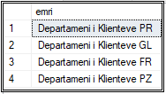

4 Te shfaqen emrat dhe mbiemrat dhe balanca e tyre e Llogarimbajtesave ?

select FirstName,LastName,Balance

from LlogariMbajtesi l,Kontoja k

where l.Id = k.AccountHolderId

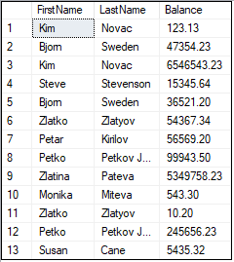

5. te shfaqen LlogariMbajtesit te cilen kan marr Kredi me kamat?

select FirstName,LastName,emri_kredis

from LlogariMbajtesi m ,Kredia a

where m.Id = a.LL_MB and emri_kredis = 'ME KAMAT'

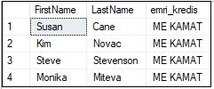

6 te Shfaqen kontot e te gjith Studenteve ?

select distinct s.Emri,s.Mbiemri, Balance

from Studenti s,DepartamentiK d,LlogariMbajtesi l,Kontoja k

where s.DP_K = d.DKL_ID and l.DepK_ID = d.DKL_ID and k.AccountHolderId = l.Id

7 Te shfaqet vetem biznesi nga Departamenti i biznesit PR ?

select emri

from DepartamentiBiznesit

where emri = 'Departamenti i Biznesit PR'



--te shfaqet emri mbiemri dhe Detyra e programerit te departamentit te IT ?

select emri,mbiemri,forma

from DepartamentiIT



-- Te shfaqen emrat dhe mbiemrat dhe balanca e tyre e Llogarimbajtesave ?

select FirstName,LastName,Balance

from LlogariMbajtesi l,Kontoja k

where l.Id = k.AccountHolderId

-- Shfaqini Bizneset te cilat gjenden ne prishtine dhe Numrin serial permes Departamentit te Biznesit, duke perdorur Subquery ?

select emriBiznesit,SN,emri

from Bizneset,DepartamentiBiznesit

where B_ID=DB_ID and DB_ID = (select B_ID 'Prishtine'

from Bizneset

where emriBiznesit = 10)

--gjeni cili llogarimbajtes ka Balancen me te madhe ?

select E.FirstName, E.LastName, max(k.Balance) as 'Balanca maks'

from LlogariMbajtesi E, Kontoja k

where E.Id = k.AccountHolderId

group by E.FirstName,E.LastName

having max(k.Balance) >=all(select max(k.Balance)

from Kontoja k, LlogariMbajtesi E

where k.AccountHolderId=E.Id )



----Shfletoni emrin e biznesit dhe Serial NR te cilete nuk gjinden ne Departamentin e Biznesit ?( me JOIN )

select P.emriBiznesit, P.SN

from Bizneset P

where P.B_ID NOT IN (Select K.DB_ID

from DepartamentiBiznesit K

where K.DB_ID=P.DB_ID)



4. VIEW

--Krijimi i VIEW per te gjetur listen e Bilancit te Studenteve te cilet kan me pak se 300 Euro ?

--

create view [get Student by Money]

as

(

select B.emri,B.mbiemri,B.Bilanci

from Studenti B

where Bilanci <= 300)

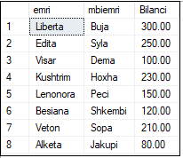

-- shfaqi Bilancin e studenteve duke e perdor VIEW -n e me heret ne mes te 100-250 euro ?

select *

from [get Student by Money]

where Bilanci between '150' and '250'

order by Bilanci DESC

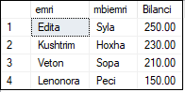

-- Te shfaqet edhe Vlera Maksimale e bilancit te studentit ( duke shfrytzuar VIEW )?

select max(Bilanci) as 'Vlera Maksimale'

from [get Student by Money]

